Web-Based WAU Order Management Tool Specification
Revision: 6.00
Date: 4th Sep 2006

Revision | Date | Author | Description
001 | 21 May 2006 | Dennis Low | Draft version
002 | 02 Jun 2006 | Yusming | Revised requirements.
003 | 06 Jun 2006 | Yusming | Revised requirements
004 | 16 June 2006 | Poh Lin | Revised requirements
005 | 21 August 2006 | Jolene Chong | Revised requirements
006 | 4th Sep 2006 | Yusming | Revised requirements

Background
WAU (Windows Anytime Upgrade) Order Fulfillment System is a web-based solution provided by BAX Global to manage the end-to-end supply chain solution for the launch of WAU. It is an “Order from Store” business model and is available 24 x 7. The tool requires minimal human intervention whilst enabling orders to be fulfilled via the web from requestor to delivery to end-consignee. For maximum security, user access is assigned and controlled by Microsoft.

Roles and Responsibility
The WAU Order Fulfillment System brings together 4 parties who each play an integral role in the fulfillment of the shipment:

1) Requestor
Role: To raise the order in the system for fulfillment
Responsibility: Ensure order entry is accurate
Ensure order is complete and confirmed before submission
In the event of order cancellation, to send request via email to Microsoft

2) MTV (Mentor Singapore and Moduslink Singapore)
Role: To fulfill order from stock and pick/pack per order requirement
To build and replenish stock as per authorization from Microsoft
Responsibility: Ensure products pick (SKU and quantity) are as per ordered by
Requestor
Ensure products are packed properly and in a sturdy manner for transportation
Ensure pallets are labeled correctly
Liaise with FF for freight collection
Notify Microsoft and FF immediately should exceptions occur that can impede the shipment

3) Freight Forwarder (FF) BAX
Role: To transport the product ordered via selected transport mode (Air/Ocean) to End-Consignee on DDP Terms
Responsibility: Ensure shipments are picked up on time from MTV
Ensure shipments picked up are correct i.e. SKU and quantity match the freight booking
Ensure Pre-alert is sent to destination with shipping paperwork i.e. HAWB/BOL, Commercial Invoice and Packing Lists are attached for customs clearance
Ensure shipment is uplifted as per scheduled flight/vessel
Ensure POD for shipments are provided to Microsoft in a timely manner.

4) MS VAM:
Role: The overall administrator of the order fulfillment system
Responsibility: Ensure PR for inventory replenishment is approved
Facilitate order cancellation as requested by Requestor
Generate reports from the system to monitor inbound and outbound activities

Requestor: Given ID and password to access the web application to raise the orders
MTV: Given ID and password to access the web application.
View the build request,
Build and pack according to request.
Work with BAX for the freight requirement

BAX: Provide freight management services to MS
Update shipment information ie MAWB# and HAWB#
Provide POD to the system

WAU Web-Based Order Fulfillment System
MS VAM: Given ID and password to access the web application
- Verify and approve PR for stock replenishment
- Facilitate ad-hoc shipment arrangements

Key Contacts & Escalation
MTV
Name | Designation | Email | Direct Line | Mobile
Wong Yen Yen | Program Manager | mentor@mmedia.mis.com.sg | +65 68963893 | +65 96444378
Delphine Yeo | Business Development Manager | delphine_yeo@mmedia.mis.com.sg | +65 68963884 | +65 96937389
Joycelyn Chua | Senior Account Executive | sing-ams@moduslink.com | +65 68859624 | +65 96866243
Daphne Tan | Business Manager | daphne_tan@moduslink.com | +65 68859426 | +65 96705864

BAX Global
Name | Designation | Email | Direct Line | Mobile
Alan Yeo | Air Export – CS Officer | alan.yeo@baxglobal.com | +65 6541 0807 | n/a
Julie Chew | Executive - Acct Mgmt. | Julie.chew@baxglobal.com | 65491343 | n/a
Florence Tan | Account Management, Manager | Florence.tan@baxglobal.com | +65 65491301 | +65 97535277
Mary Choo | Ocean Export – Executive | Mary.choo@baxglobal.com | +65 6549154 | n/a
Belinda Neo | Ocean Export - Supervisor | Belinda.neo@baxglobal.com | +65 65491253 | n/a
Colin Koh | Ocean - Manager | Colin.koh@baxglobal.com | +65 65491258 | +65 96551225
Dennis Low | IT Support | Dennis.low@baxgobal.com | +65 65491343 | n/a
Ng Poh Lin | Regional Acct Manager | Pohlin.ng@baxglobal.com | +65 65491413 | +65 96386190

Microsoft
Name | Designation | Email | Direct Line | Mobile
Jamie Chua | Manufacturing VAM | jchua@microsoft.com | +65 63709196 | +65 96879815
YY Leow | Distribution Manager | dtvsg@microsoft.com | +65 63709139 | +65 97663406
Order to Fulfillment Process
Requestor
- The requestor logs on to the designated website and keys in his/her user id and password
- Upon successful log-on, requestor can proceed to raise order by entering order details into relevant fields and submit the request via the tool
- The request is then vetted by the tool for consignee destination.
  - For AOC and EOC destination, the tool will send an email to MS designated parties to action accordingly, physically shipment will be performed and completed by the AOC and EOC appointment entity.
  - For APJ destinations (China & Japan), the tool will run a backend check on the inventory and allocate the available inventory. China’s Jit Hub will fulfill orders coming from China’s ARs, whereas BAX Singapore APOC will fulfill orders coming from Japan. In the event where there is insufficient stock, the tool will trigger a PR to MS VAM for stock replenishment.
- There is a daily scheduler, that runs at mid-night (0000hours), to consolidate all orders by end-consignee. This is to enable physical pick/pack consolidation should multiple orders for the same consignee be entered on the same day.

Freight Booking:
- At 0600hrs, the tool will trigger an email to the MTV containing the pick list as well as trigger a freight booking with the FF
- The pre-determined collection time from the MTV is 1300hrs the same day
- FF will match the SKU# and quantity with their booking form before collection
- The FF will access the tool to enter key shipment information to trigger the invoice and packing list
- FF will sort the shipments collected by consignee and attach the relevant shipping documents accordingly
- FF will then email to Requestor and MS the shipment details and attach the shipping documents

Freight Shipped:
- FF will uplift the shipments as per flights scheduled
- FF will update the POD into the tool

Order Fulfillment Flow

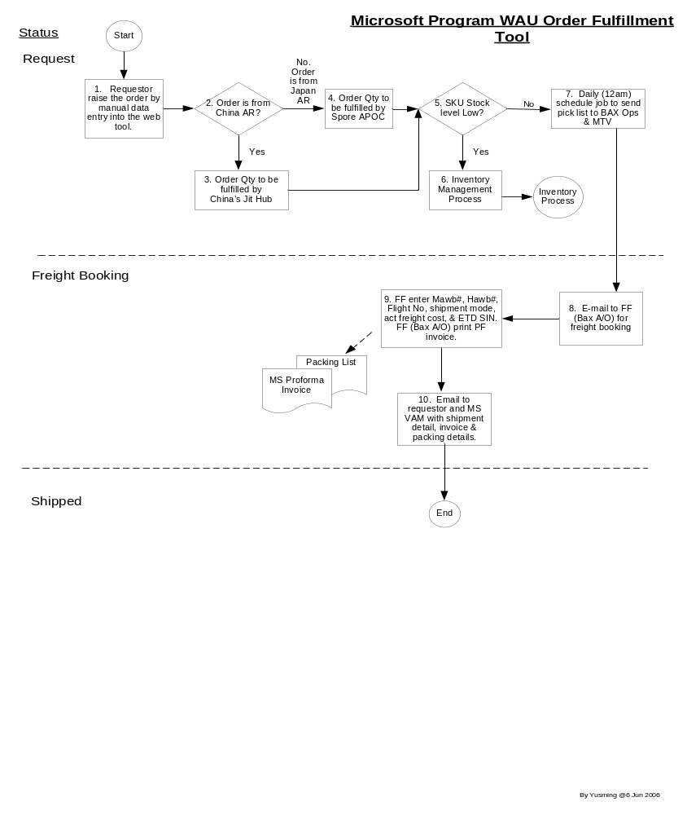

Inventory Fulfillment Process
PR Process (Requisition for WAU Inventory build)
- For APJ destinations (China & Japan), the tool will run a backend check on the inventory and allocate the available inventory. In the event when there is insufficient stock, the tool will trigger a PR to MS VAM for stock replenishment.
- MS Admin can either review/adjust the PR before approving.
- Upon approved, the system will trigger the tool to generate a PO to the MTV

PO Process
- MTV will receive the PO via email
- Upon build completion, MTV will access the tool to update the build completion date and new stock quantity
- MTV will perform GR with Work Order information. Data entry will be performed on per pallet qty basis.

GR Process (Goods Receipt)
- The GR process is completed when the new stock is inventorised in the tool
- An email is triggered to MS Admin to notify that the stock is replenished.

Inventory Fulfillment Flow
Following are the proposed flow for WAU inventory fulfillment;

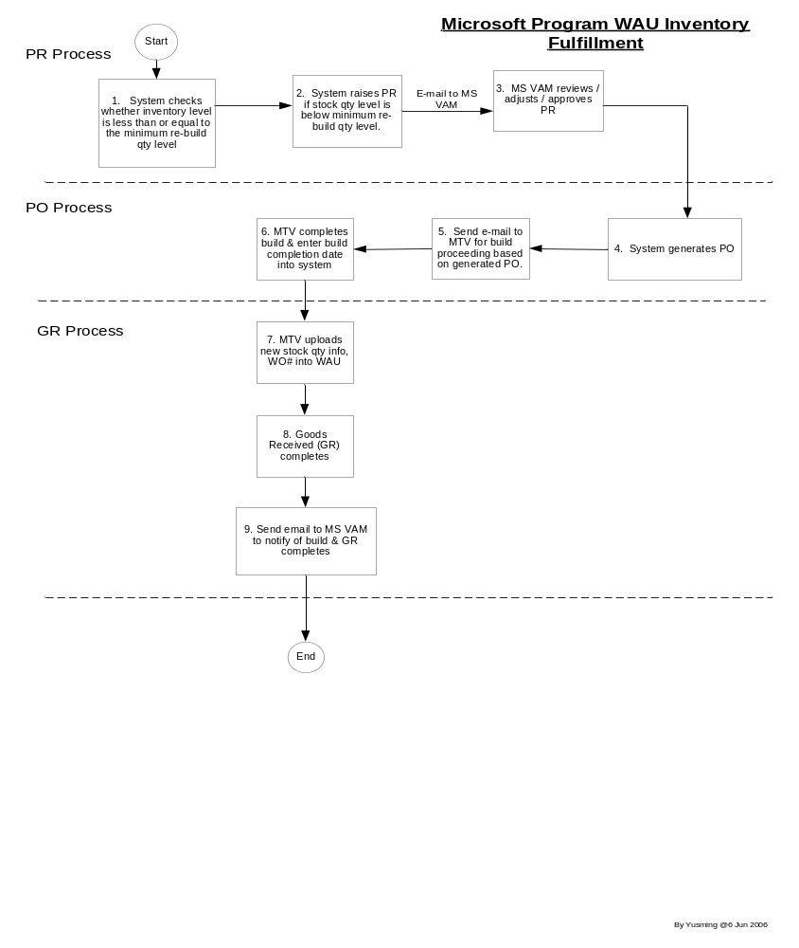

Business Rules Assumptions
Rules
- One Work Order Number = One Job Number = One Pallet = One SKU,
- MTV(s) are not allowed to view ship-to party,
- MTV to perform GR,
- Maintain Min, Max stock level,
- Freight rate to be build into the application,
- PO management
- WO# = Pallet ID
- Job # = Order Reference # = DO# = Invoice#
- PR# in a prefixed running number
- Pick slip # in a prefixed running number
- Pick slip = packing list
- SKUs are predetermined by respective MTVs

Data Gathering
- Total of 12 SKUs,
- Total of 2 MTV as of now,
- Number of requestors (AR) = 73,
- Shipment out to AP countries,
- 1 Pallet = 4800 units

Data Elements

Data Element | Update By
Ship To Information | Requestor
Bill To Information | Requestor
Reference No | Requestor
Company code | Requestor
IO Number | Requestor
Part Number | Requestor
Description | Requestor
Order Qty | Requestor
Product Family | Requestor
Deliver Date | Requestor
HTS Code | Requestor
MTV | MS VAM
Est. Wgt | MS VAM
FF | MS VAM
Mode of Transport | MS VAM
PO# | MS VAM
Inv# | MS VAM
DO# | MS VAM
Cost | MTV
Completion Date | MTV
MTV Reference | MTV
Package | MTV
Dim (L*W(H) | MTV
Wgt | MTV
PickUp Date/Time | MTV
HAWB | FF
MAWB | FF
Flight/Vessel | FF
Delivery Date | FF
Profoma Invoice # | System assign same as MS Inv#

Project Man-Day

Task | Man-Day
Analysis and Design | 4
IT Development ;  - Order entry screen, (6 days)  - e-mail routing, (2 days)  - MS VAM update screen, (1day)  - MTV updating screen, (1 day)  - FF updating screen, (1day)  - Freight estimation screen, (1 days)  - Printing of Proforma Inv (1 days)  - Printing of Pick Slip (1 days)  - Inventory mgt (2 days)  - PO Management (3 days)  - Packing list & shipping mark/label (1 days)  - Audit Trails (1 day)  - Reports (2 days) *max 5 reports only | 23
Testing | 3

Signoff
Total | 30

Project Time Line
IT Development (Phase1-Order Mgt) 5 Jun 2006 to 7 Jul 2006
IT Development (Phase2-Inv Mgt) 10 Jul 2006 to 21 Jul 2006
Training and UAT 10 Jul 2006 to 21 Jul 2006
Review on UAT 24 Jul 2006
Target Live Sept 2006

